Title:
The Impact of Social Media and Smartphone Usage on Mental Health and Well-Being:
An Analysis Using the Canadian Internet Use Survey (CIUS 2022)

Authors:
Chinenye Onyedika
Nene Ikwuoma Tenabe
Rupinder Kaur
Shivam Rana
Jobit James
Course: Capstone Project

ABSTRACT
This project examines the relationship between social media and smartphone use and mental health and well-being among Canadians, utilizing data from the Canadian Internet Use Survey (CIUS 2022). The analysis investigates emotional effects, the impact of online activity on daily life, communication patterns, and variations in mental well-being across demographic groups.
Python facilitated data cleaning, feature engineering, and exploratory data analysis (EDA). Tableau was employed to generate visual dashboards that highlight key indicators, including emotional distress, anxiety, screen-time interference, and communication frequency.
The findings indicate that emotional strain and interference with daily life are highest among adults aged 35 to 44, whereas younger adults report lower levels of anxiety than anticipated. Older adults (65 and above) demonstrate the most stable communication habits. Additionally, household type and income influence digital engagement and well-being outcomes.
This study demonstrates the effects of social media and smartphone use on Canadians across various age groups and life stages. The results may inform strategies to promote healthier digital habits and improve mental well-being.

INTRODUCTION
Motivation
Social media and smartphones have fundamentally changed the ways in which Canadians connect, communicate, work, and access information. Although these technologies offer convenience and social support, increasing concerns have emerged regarding their impact on mental health, such as heightened anxiety, emotional distress, and disruptions to daily routines.
Understanding who is most affected, and how usage patterns differ across demographics, is essential for policymakers, educators, mental-health practitioners, and technology designers. The CIUS 2022 dataset provides a unique national perspective on these issues.
Objectives
The objectives of this project are to:
- Analyse the relationship between social media and smartphone usage and their association with emotional distress and interference in daily life.
- Examine mental well-being differences across age groups, income levels, provinces, and household types.
- Investigate communication habits and their relationship to perceived well-being.
- Develop dashboards to visualize key patterns in mental health and technology usage.
- Provide recommendations to promote healthier digital engagement.

METHODOLOGY
Data Source
- Dataset: Canadian Internet Use Survey (CIUS 2022)
- Provider: Statistics Canada (Public Use Microdata File)
- Sample Size: ~19,000 respondents
- Focus Variables: Social media usage, smartphone use, emotional distress, anxiety indicators, communication frequency, interference with daily life, demographics

Data Cleaning & Preparation (Python)
Major steps:
- Selected mental-health and social-media-related variables
- Cleaned categorical fields (age, province, gender, income, household type)
- Converted “Not Asked” and “Unknown” into meaningful categories
- Created binary KPIs:
  - Emotional distress
  - Online interference
  - Daily communication
- Performed weighted calculations to match national survey design
- Conducted descriptive and comparative EDA
- Produced heatmaps, bar charts, and trend visualizations

Dashboard Development (Tableau)
Two dashboards were created to visualize:
1. Mental Health & Online Behavior
- Emotional distress by age
- Online interference by age
- Daily communication by household type
- Filters for Province and Age
2. Social Media, Smartphone Usage & Well-Being
- Overall well-being indicators
- Communication frequency
- Smartphone/social media usage patterns
- Demographic comparisons
Dashboards emphasize clarity, color consistency, and meaningful tooltips.

DATA ANALYSIS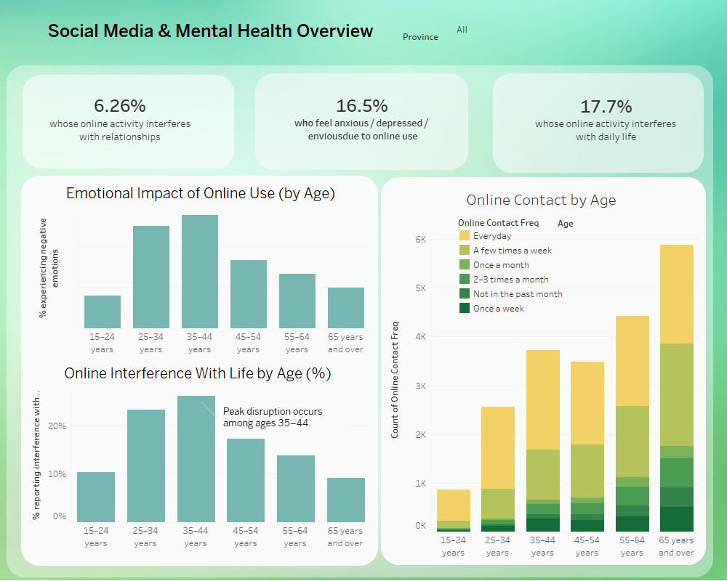
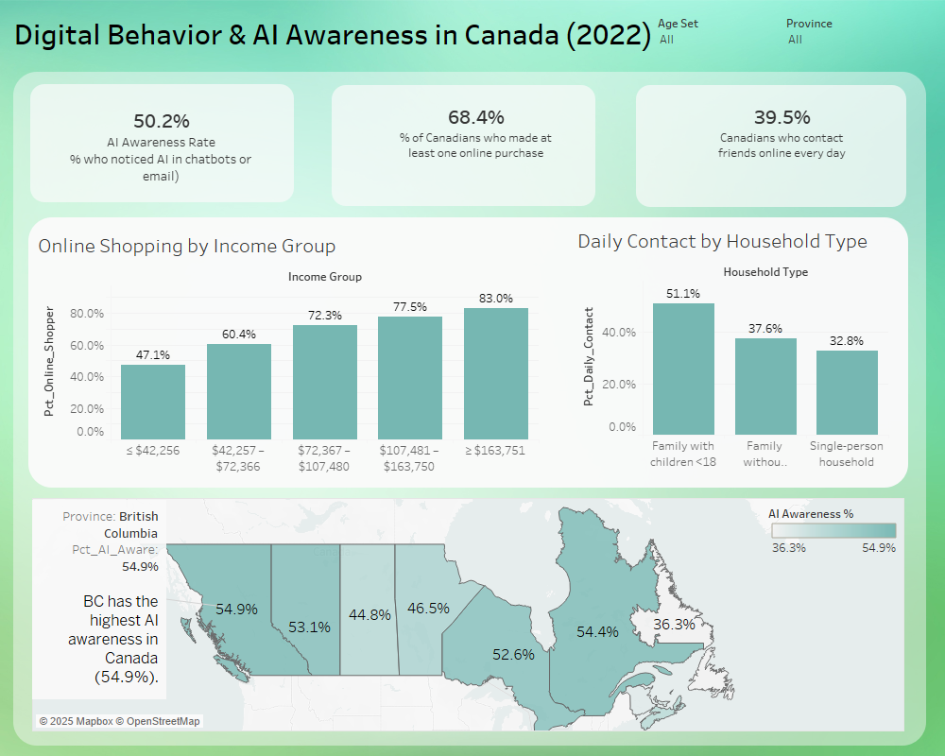

1. Emotional Distress and Anxiety
- Emotional distress is highest among individuals aged 35 to 44 years.
- Individuals aged 15 to 24 report lower levels of anxiety, even though their social media usage is high.
- Reported emotional distress decreases significantly after age 45.

These findings suggest that mid-life adults encounter unique stressors related to career, family responsibilities, and digital multitasking.

2. Online Interference with Daily Life
- Adults aged 35 to 44 report the highest level of disruption from smartphone and social media use, at approximately 26 percent.
- Adults aged 65 and older report minimal interference, at approximately 10 percent.
These results indicate that working-age adults may be particularly vulnerable to digital overload.

3. Communication and Social Connectedness
- Adults aged 65 and older maintain the most consistent online contact with friends and family.
- Contrary to common assumptions, younger adults do not exhibit the highest frequency of online communication.
- Families with children (<18) show 51% daily communication — the highest of aThese findings suggest that older adults and families with children rely extensively on digital tools to maintain social connections. connection.

4. Smartphone and Social Media Usage Patterns
- Individuals in higher income groups use smartphones more actively for daily communication and digital tasks.
- Single-person households demonstrate lower frequencies of communication and greater variability in reported well-being.
- Increased screen-time interference is correlated with higher levels of emotional strain.

INTERPRETATIONS & LIMITATIONS

Interpretations
- Emotional strain appears most pronounced during mid-life, which may be attributed to increased work-life pressures and extensive digital multitasking.
- Although younger adults are frequent users of social media, they may experience reduced anxiety as a result of the social normalization of digital communication.
- Older adults tend to exhibit healthier and more stable digital habits, utilizing technology primarily for meaningful communication.
- Household structure has a significant impact on patterns of online communication and overall emotional well-being.

Limitations
- CIUS is self-reported, introducing potential bias.
- Survey routing creates “Not Asked” categories that limit some comparisons.
- Several key variables, such as time spent on applications, specific social media platforms used, and clinical mental health diagnoses, were not included in the analysis.
- Because the study employs a cross-sectional design, causal relationships cannot be established.
- Smartphone and data usage were assessed behaviorally rather than quantified in terms of minutes or hours.

RECOMMENDATIONS & FUTURE WORK

Recommendations
- Implement mental well-being programs specifically designed for adults aged 25 to 44.
- Promote balanced smartphone usage by utilizing digital wellness reminders and screen-time management tools.
- Facilitate healthy online communication among socially isolated populations, such as individuals in single-person households.
- Provide educational resources to families on effective management of online communication and screen-time boundaries.

Future Work
- Machine Learning: Predict emotional distress using online-activity variables.
- Cluster Analysis: Identify “digital behavior personas” based on social-media and communication patterns.
- Time-Series Research: Compare CIUS 2020 vs 2022 to examine post-COVID mental-health changes.
- Dashboard Expansion: Add gender, income, household filters and correlation heatmaps.
- Incorporate External Research: Compare CIUS findings with academic literature on smartphone and social-media psychology.

APPENDIX:
Column selection :
cols16 = [
"PROVINCE", "AGE_GRP", "GENDER", "EDU", "EMP", "HINCQUIN", "WTPG",
"TS_010A", "TS_020A", "UI_110A", "UI_110B", "UI_110C",
"DS_070A", "DS_070B", "GHCOMP", "ONL_SHOP"
]
column_mapping = {
"PROVINCE": "Province",
"AGE_GRP": "Age",
"GENDER": "Gender",
"EDU": "Education",
"EMP": "Employment",
"HINCQUIN": "Income_Group",
"WTPG": "Weight",
"TS_010A": "Rel_Satisfaction", # satisfaction with relationships (friends)
"TS_020A": "Online_Contact_Freq",# how often use internet to communicate with friends
# UI_110* are *effects* of online use
"UI_110A": "SM_Interfere_Rel", # Does online use interfere with relationships?
"UI_110B": "SM_Interfere_Life", # Interfere with other aspects of life?
"UI_110C": "SM_Anxious_Envious", # Make you feel anxious / depressed / envious?
# DS_070* are *AI awareness*, not stress/sleep
"DS_070A": "SM_AI_Chatbot", # Ever noticed AI in chatbots?
"DS_070B": "SM_AI_Email", # Ever noticed AI in emails?
# Household composition
"GHCOMP": "Household_Type",
# Online shopping
"ONL_SHOP": "Online_Shopping"
}
cius = cius.rename(columns=column_mapping)
cius.columns
Index(['PUMFID', 'Province', 'LUC_RST', 'RRS_G12', 'Age', 'Gender', 'ABM',
'Employment', 'ED_10', 'Education',
...
'WRPG991', 'WRPG992', 'WRPG993', 'WRPG994', 'WRPG995', 'WRPG996',
'WRPG997', 'WRPG998', 'WRPG999', 'WRPG1000'],
dtype='object', length=1342)

cius_df.info()
<class 'pandas.core.frame.DataFrame'>
RangeIndex: 25118 entries, 0 to 25117
Data columns (total 16 columns):
# Column Non-Null Count Dtype
--- ------ -------------- -----
0 Province 25118 non-null object
1 Age 25118 non-null object
2 Gender 25118 non-null object
3 Education 25118 non-null object
4 Employment 25118 non-null object
5 Income_Group 25118 non-null object
6 Weight 25118 non-null float64
7 Rel_Satisfaction 25118 non-null object
8 Online_Contact_Freq 25118 non-null object
9 SM_Interfere_Rel 25118 non-null object
10 SM_Interfere_Life 25118 non-null object
11 SM_Anxious_Envious 25118 non-null object
12 SM_AI_Chatbot 25118 non-null object
13 SM_AI_Email 25118 non-null object
14 Household_Type 25118 non-null object
15 Online_Shopping 25118 non-null object
dtypes: float64(1), object(15)
memory usage: 3.1+ MB

import matplotlib.pyplot as plt
import seaborn as sns
sns.set(style="whitegrid")
# List of final columns for univariate EDA
cols = [
"Province", "Age", "Gender", "Education", "Employment",
"Income_Group",
"Rel_Satisfaction", "Online_Contact_Freq",
"SM_Interfere_Rel", "SM_Interfere_Life", "SM_Anxious_Envious",
"SM_AI_Chatbot", "SM_AI_Email",
"Household_Type", "Online_Shopping"
]
# Function to plot bar charts for categorical variables
def plot_bar(col):
plt.figure(figsize=(10, 4))
cius_16[col].value_counts().plot(kind='bar', color='steelblue')
plt.title(f"Distribution of {col}", fontsize=14)
plt.ylabel("Count")
plt.xticks(rotation=45, ha='right')
plt.show()
# UNIVARIATE ANALYSIS
for col in cols:
print(f"----- {col} -----")
print(cius_16[col].value_counts())
plot_bar(col)

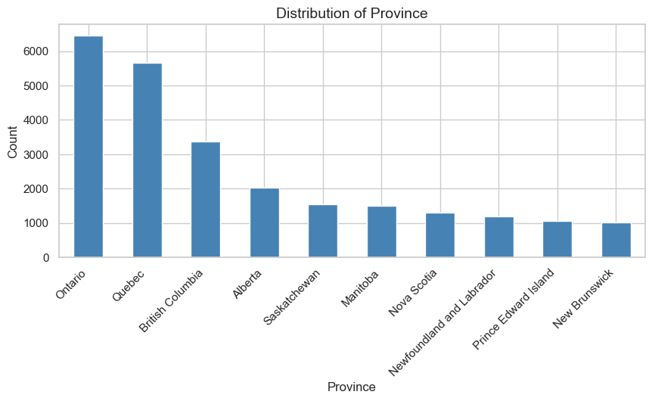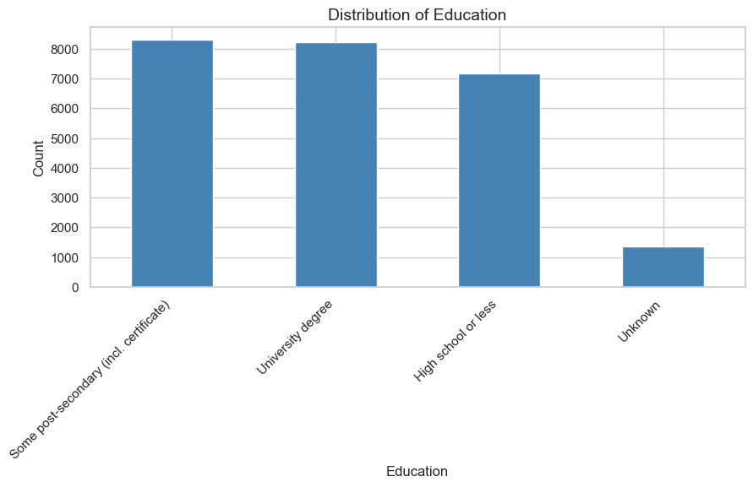

BiVariate Analysis

Age × Social Media Mental Health (Anxiety / Interference)
plt.figure(figsize=(12,5))
sns.countplot(data=cius_16, x="Age", hue="SM_Anxious_Envious")
plt.xticks(rotation=45)
plt.title("Age vs SM Anxiety/Envy")
plt.show()
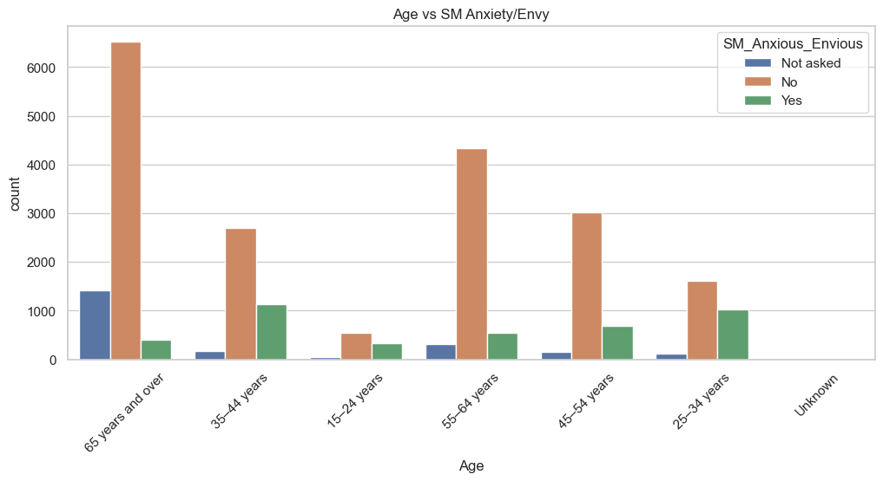

Age × Online Contact Frequency
plt.figure(figsize=(12,5))
sns.countplot(data=cius_16, x="Age", hue="Online_Contact_Freq")
plt.xticks(rotation=45)
plt.title("Age vs Online Contact Frequency")
plt.show()
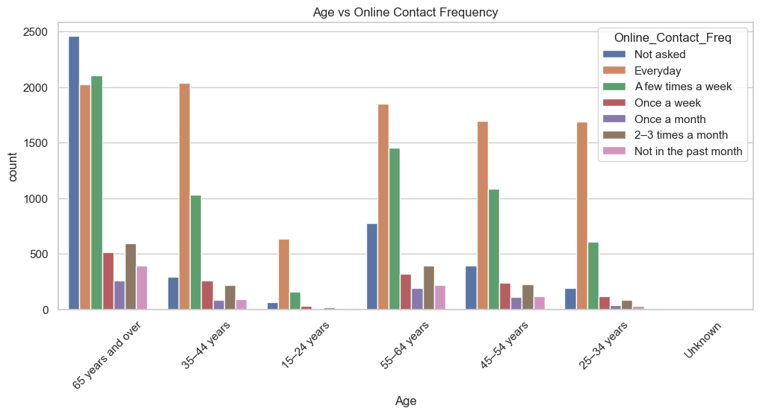

REFERENCES

- Statistics Canada. Canadian Internet Use Survey (CIUS) 2022.
- Tableau Desktop Documentation.
- Python libraries: pandas, numpy, seaborn, matplotlib.

